Supplementary Information
Santos et al. Seed gut-passage through fish
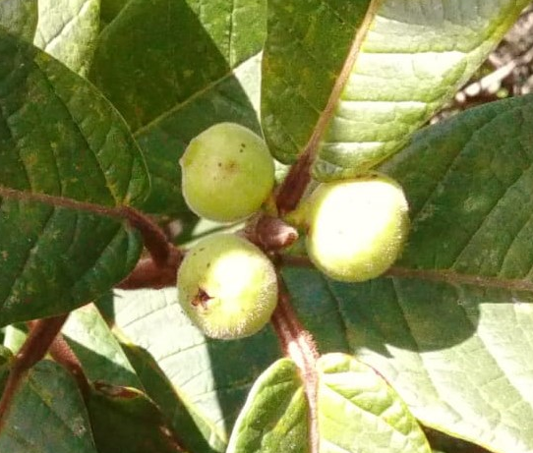
d
c
b
a

Figure S1: (a) Study area in the Teles Pires River, Mato Grosso, Brazil, where Brycon falcatus was collected during May of 2018. (b) Fruiting Ficus gomelleira (Moraceae) trees on the bank of the Teles Pires River during the wet season; inserted box shows ripe syconia. (c) A school of young B. falcatus foraging at a tributary stream of the Teles Pires River. (d) An individual of B. falcatus photographed after the experiments (~13 cm total length). The rapids in the image (a) and the tributary stream (c) were flooded by the filling of the Sinop Hydroelectric Dam between March and April of 2019; the area is currently a lake. There are currently four hydroelectric dams operating in the Teles Pires River.
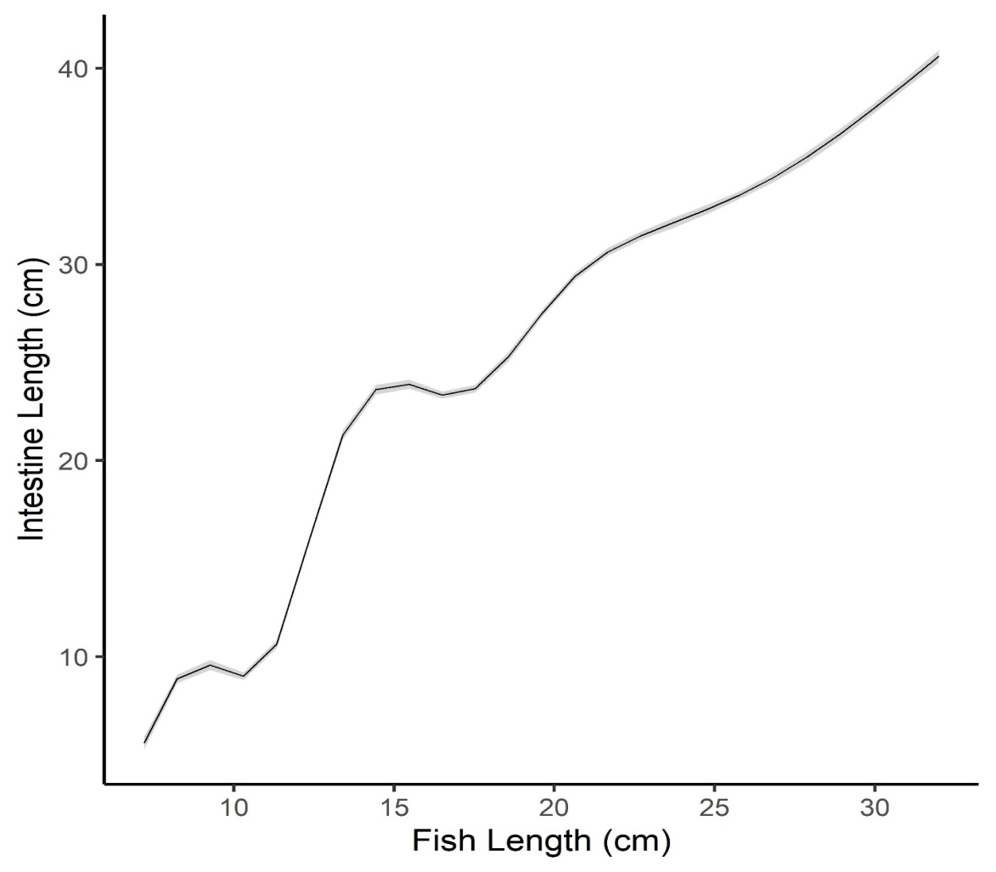
Figure S2: A Generalized Additive Model shows variable increase in intestine length with fish length for Brycon falcatus.

