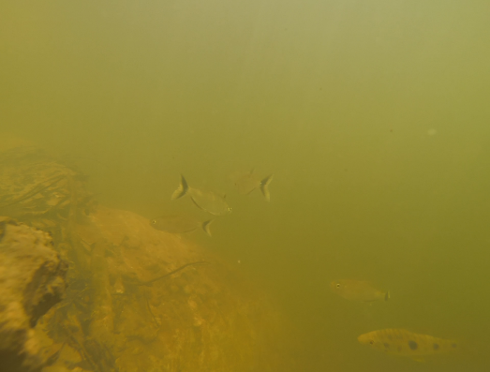
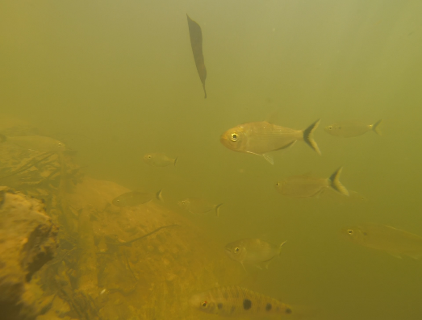
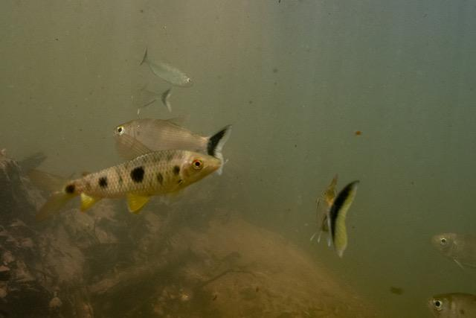

SUPPORTING INFORMATION
Video S1. Video recording a school of B. falcatus and an individual of L. friderici at the bottom of the stream in Southern Amazon, Brazil.
Fig. S1. The sequence images from stream bank showed an individual of threespot leporinus (Leporinus friderici) moving from the bottom of the stream to the upper stratum of the water column occupied by the matrinxã (Brycon falcatus).

